Large Model Aircraft
I’ve put this very brief guide together for those who have never had experience of building and flying large model aircraft.
What do we mean by large?
The legal definition of a large model aircraft is an aircraft weighing more than 7kg (15.5 lbs.). There is of course a correlation between the size of a model and its weight, but this can be a grey area for models such as gliders and electric aircraft. It all depends on the models construction, its intended power source, its flying capabilities and of course the builder. An example of this is Dave Berry’s Comet airliner with 4 electric motors. It weighs about 7lbs and has a wingspan of around 86”. A big model but very light.
In America for example, many people tend to build heavier aircraft than if they were built in this country. Weights and power plants vary hugely as do the types of wood used, the amount of glue used and the level of detailing applied.
Many people don’t think that they will ever build a model weighing more than 7kg, but of course this can and usually does happen to many of us. With ever increasing reliability of radio systems and engines, more people are building large models.
Building
Most large models are built from either kits, or plans, however there are an increasing number of ARTF models on the market which qualify as large. How the model is designed and constructed is crucial to ensuring the aircraft is strong and as light as it needs to be for its size, power plant and flying style.
Building large model aircraft requires even more consideration than that of smaller models. High stress areas such as firewall, tail plane, undercarriage wing spar and wing mounting need particular attention. The use of 24hr epoxy glue in these areas is crucial; to ensure that structural integrity is maintained. Reinforcing high stress areas such as the firewall/fuselage side with carbon cloth is also a useful method of adding additional strength, with limited weight gain. Using the correct type of wood for the area of the aircraft is also important. The use of plywood and liteply (balsa sandwiched between thin plywood) has increased in recent years. This provides more strength than balsa wood on its own. Hardwood spars rather than balsa spars are also key in large models.
The fitting of dual receiver batteries and dual switches is useful to increase reliability and is something I do for all of my larger models. I also ensure all my aircraft are fitted with at least 3 hinges per surface, as if 1 fails, there are still 2 more, hopefully in place.
Flying
Flying large models is much the same as flying small models, but requires more consideration of airspace and air speed. Larger models look slower in the air, so the pilots perception of how fast the model is flying can be incorrect. With the exception of high performance aerobatic models, large models need to be flown more like a full size aircraft. They won’t leap into the air and climb vertically forever, they are more affected by crosswinds and torque effect, the use of the rudder when flying is far more important than on a smaller model. The pilot needs to consider where the aircraft he is going to fly the aircraft and what will be his next manoeuvre, as the model will be less able to dart around the sky like a smaller model would. Landings must be carefully executed, and may need longer approaches, constantly correcting with the rudder and using the throttle to maintain height. (always good practice anyway). Often a large model will not float to the strip and ‘3 point’ onto the runway, it will need to be flown all the way down and land on its main wheels.
Really large models
All models weighing more than 7kg must be fitted with a failsafe regardless of the radio system used. (Any model must use a failsafe if available see failsafe article)
All models either scratch built, kits, plans or ARTF which weigh, or are likely to weigh when completed, more than 20kg (44lbs) dry (without fuel), must be registered with the Large Model Association. The LMA appoint an inspector, usually local to your area who will guide you through the build, advising you of certain requirements and ensuring the aircraft is built correctly. He will visit you on several occasions to inspect the structure, engine, duplicated radio system and undercarriage installation etc.
Once the aircraft is complete, a pilot, either yourself, or a nominee will be required to carry out a number of test flights in private, but with witnesses and that pilot will then be certified and will be the only person legally able to fly the aircraft. Anyone else wishing to fly the aircraft must undergo assessment.
If any changes are made to the aircraft such as replacement engines, damage repair, replacement servos etc, the aircraft will have to undergo further inspection.
If the aircraft is sold, it cannot be flown until the paperwork and assessments have taken place.
For those who like warbirds, most 1/4 scale fighters (usually around 10ft span and 60-100cc) are on the limit of 20kg and if they have significant detailing, are built heavy and have particular types of engine, then they are often well above 20kg. An example of this is a Hawker Sea Fury (pictures below) built by Mick Burrell and designed by a well-known American designer, Jerry Bates. It is fitted with a Moki 250cc radial, has folding wings, and full scale detail throughout. The model has a wingspan of just less than 10ft, and weighs around 75lbs. It may be possible to build this under 20kg, but there is then the risk that it would be too light for its size and may not fly as well and of course there is the main risk that it may be weak in particular high stress areas.
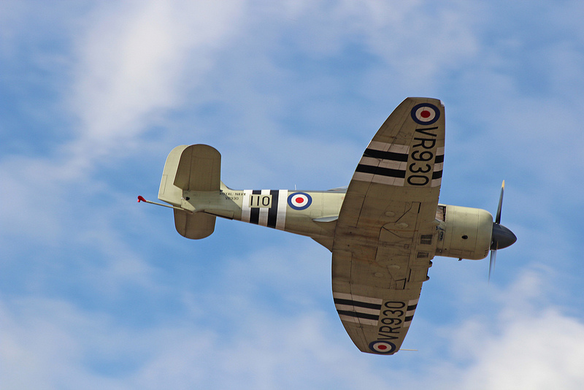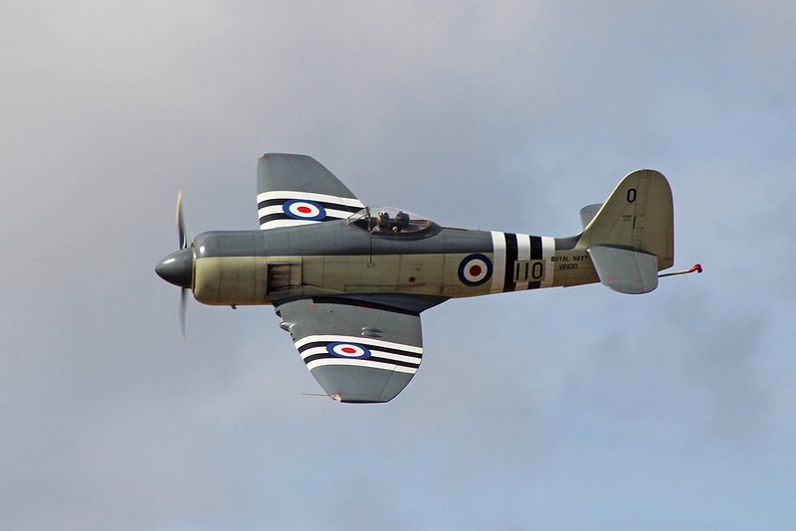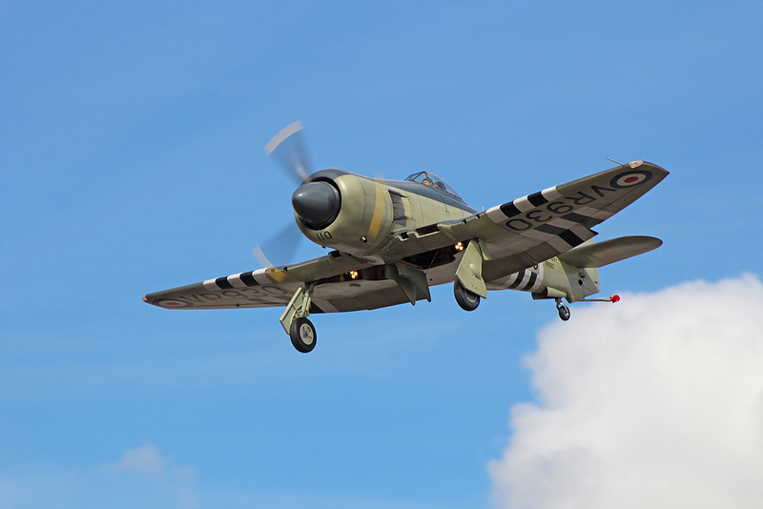
Going through the over 20kg scheme is not a problem, many people do it, however it is a legal requirement to register and have inspected an over 20kg model and quite reasonably does require additional consideration of flying site layout, flying capability and construction/modelling skills.
If a model which was once under 20kg, but for whatever reason goes over 20kg and is fully completed, then steps are taken to assess the construction based on the specific aircraft. It may require parts of the aircraft to be taken apart, covering or sheeting to be removed etc in order to fully assess it.
Chris Berry Sep 2013

